3rd Grade 2023-2024 Supply List
Welcome to 3rd Grade! We look forward to working with you to ensure a successful 2023-2024 school year. The following is a list of school supplies your child will need. Please label everything with your child’s name.
- 5 marble wide ruled notebooks (NO SPIRALS/NO College ruled)
- 5 PLASTIC pocket folders
- ELA: 1 yellow folder
- Math: 1 blue folder
- Science/Social Studies: 1 green folder
- Writing: 1 orange folder
- Take-Home/Homework folder: 1 folder of your choice of color/design
- 1 box of 24 crayons (NO MORE THAN 24)
- 1 pack of at least 4 glue sticks
- 2 packs of SHARPENED # 2 pencils
- 1 packs of loose-leaf paper (WIDE RULE)
- 1 school scissor
- 1 zipper soft pencil case (NO BOXES)
- 1 small pencil sharpener
- 1 box of 12 FINE TIP BLACK EXPO DRY ERASE MARKERS
- 1 highlighter
- Lysol wipes
- 2 boxes of classroom tissues
- 1 roll of paper towel
- A pair of wired headphones
Please label everything with your child’s name! Please be sure to purchase the specific items we have listed so that we have a smooth beginning of a productive year!
Wide-rule  marble notebooks | Plastic  pocket folder | Zippered soft  pencil case
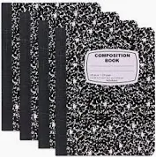 | 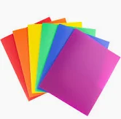 | 